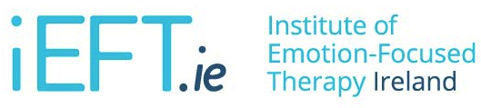

Clinician Training in
"Emotion-Focused Skills Training for Parents"
10th & 11th April 2018
Marino Institute of Education, Marino, Dublin

TRAINING REGISTRATION FORM
This workshop is aimed primarily at psychologists and psychotherapists/counsellors, but is

also open to other relevant mental health professionals (e.g., social care, social work, teaching, nursing and medicine).
NAME:

EMAIL:

PHONE:

QUALIFICATION:

REGISTRATION:
(Please provide details of registration or accreditation as appropriate)

PAYMENT DATE:
(Please provide details of payment made to account below
e.g. reference name/number)

INVOICE
EMPLOYER DETAILS:
(Where an invoice is required as payment is being made by employer, please provide employer/workplace details as appropriate)

Please make payment to the following account

Account Name: Institute of Emotion Focused Therapy Ireland
Bank: Bank of Ireland, 2 College Green, Dublin, Ireland
Account Number: 88635325
Sort Code: 900017
Bank Identifier (BIC): BOFIIE2DXXX
IBAN: IE15BOFI90001788635325

Fee: €425 (€350 early bird bookings made before 16/02/2018)

Registration is on a first come, first served basis. No refund will be given without one week’s notice of cancellation.

The Institute of Emotion Focused Therapy, Ireland is an accredited isEFT institute.
www.ieft.ie | www.iseft.org

